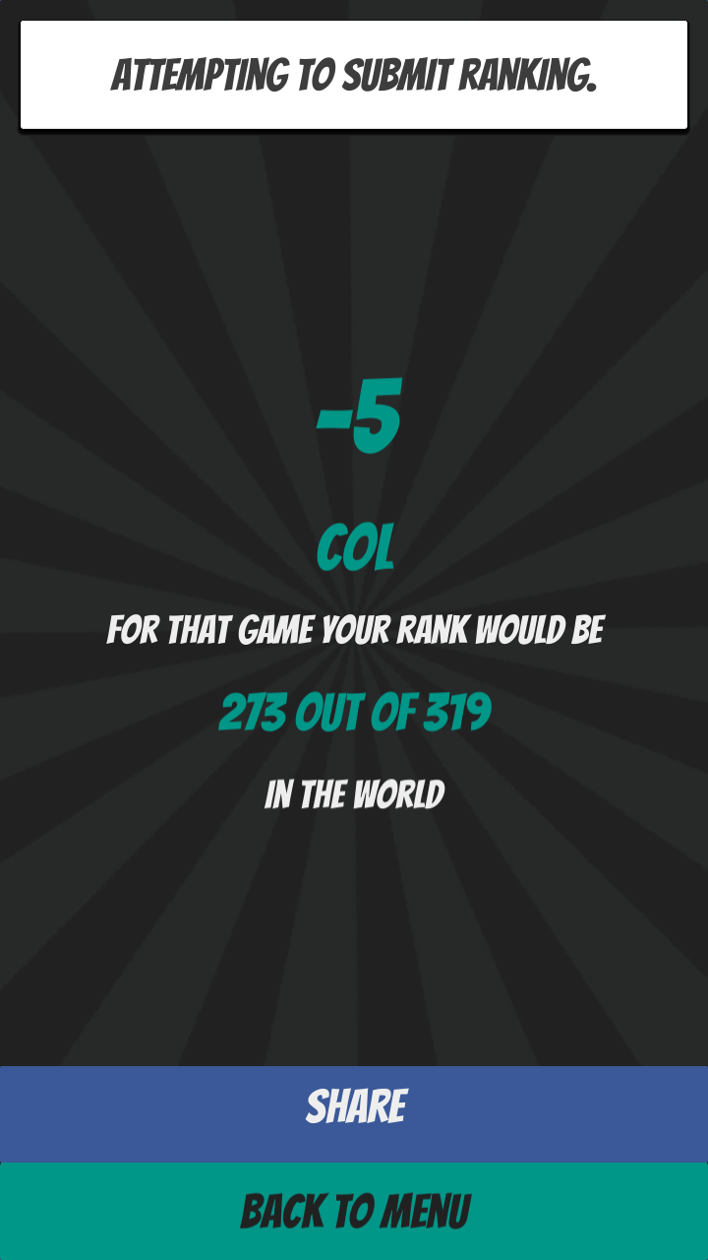I don’t think this page is scene is where the game should finish. I think maybe a results page where it shows what questions you got wrong or just straight to the leader boards, what do you guys thing?

For me ATTEMPTING TO SUBMIT RANKING will not clear.

There should be ‘you score was’ or some explaination of what the big number is

If your not logged into face book the ‘SHARE’ button shouldn’t be there.

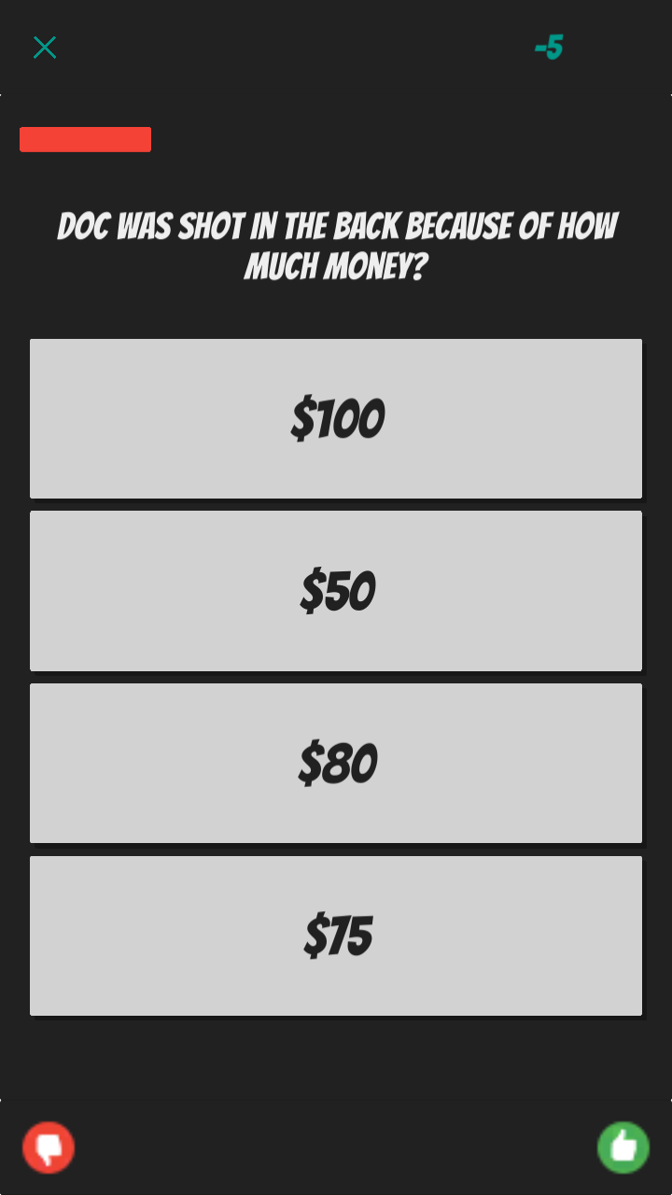For the final version I think the timer should be 30-45 seconds as 20 is very short

The time in seconds is not displaying

I think the question font should be a bit bigger, maybe we could shift the answer panel down to give some more room to the question text panel?

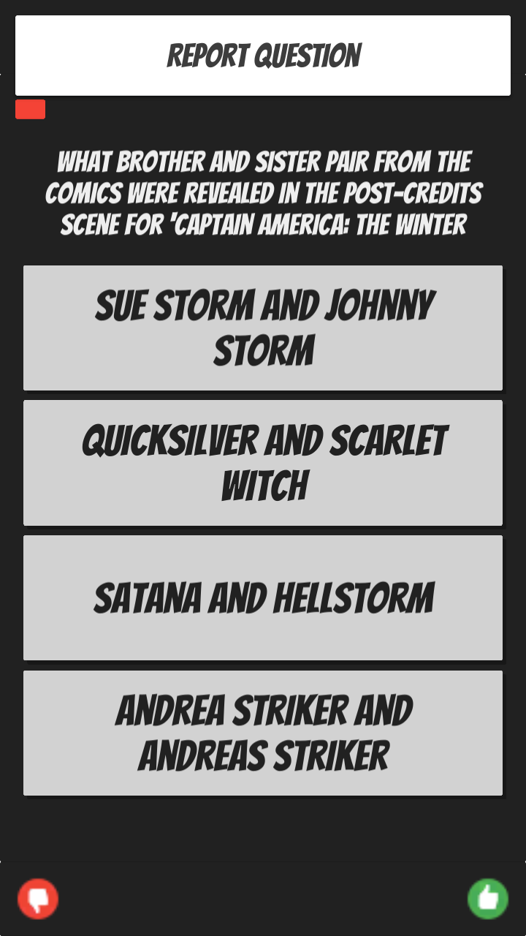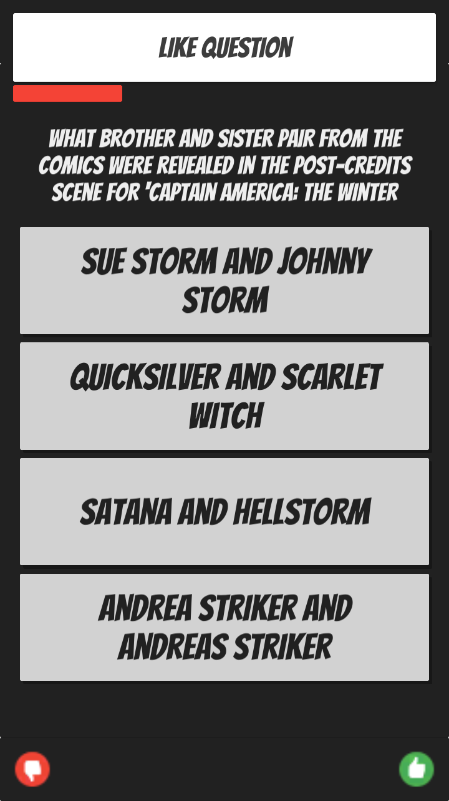“LIKE QUESTION” should this be ‘question liked’? to indicate that you have actually liked the question by cliking that button?

Similar here, report question is more of a question then a confirmation of an action

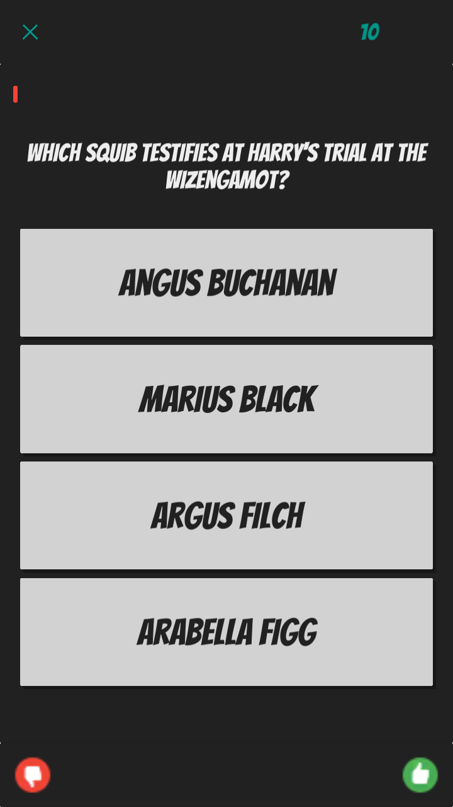I get this stupid line when I go to enter text into the text boxes. Does anyone else get that?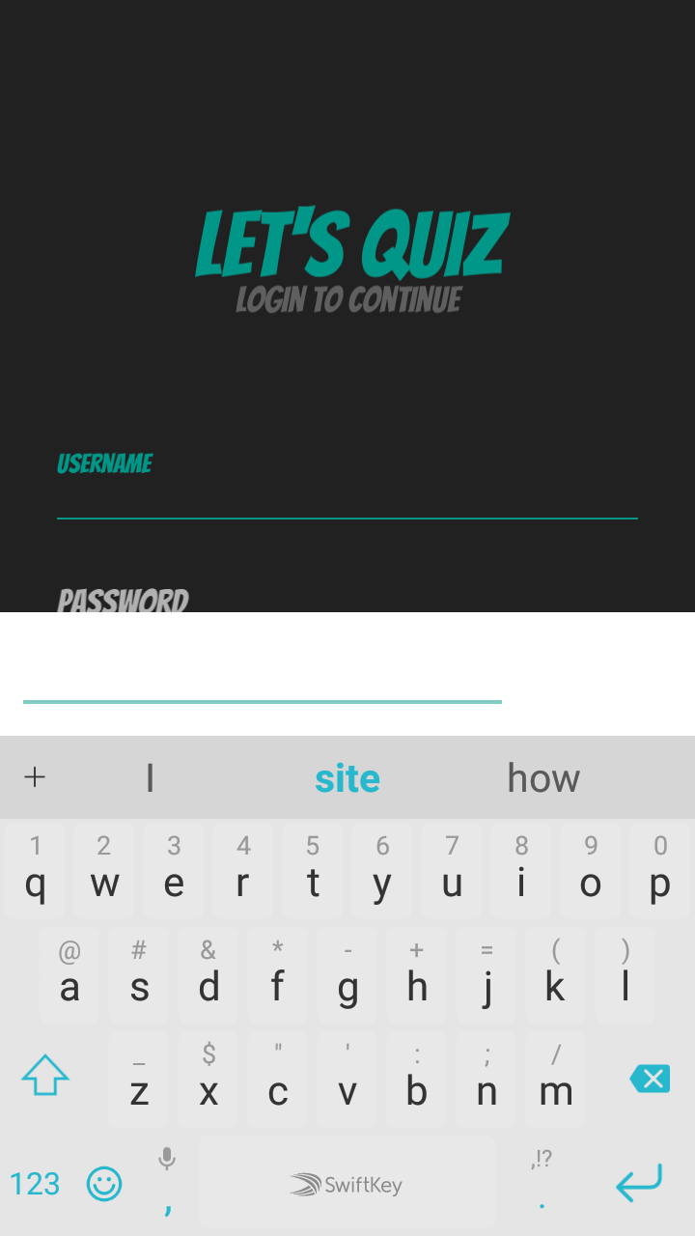

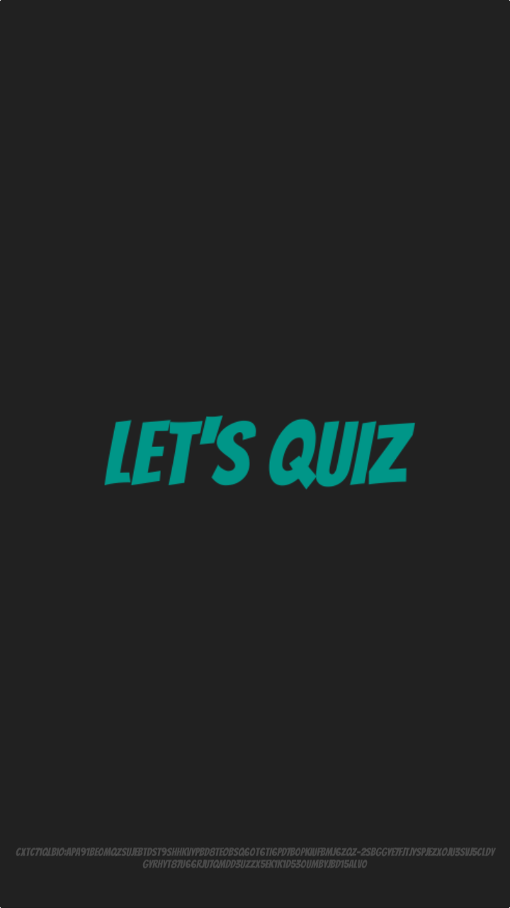

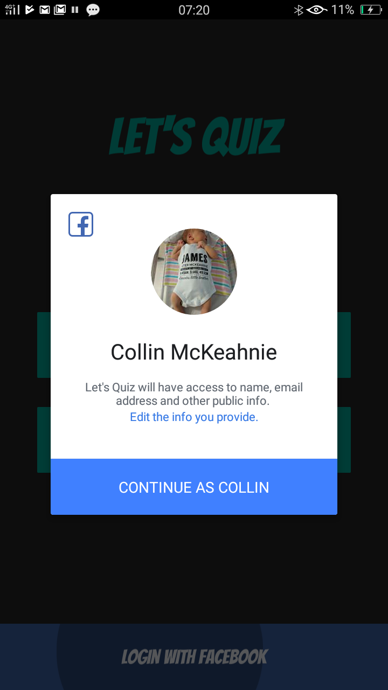When I select ‘log in with facebook’ this pop up presents then disappears but I stay on the login scene.

If it is logging me in it needs to move to the main menu, if it is erroring out I need an alert

I am still getting that white border on the category selection pop up

Also still cannot select Star Wars

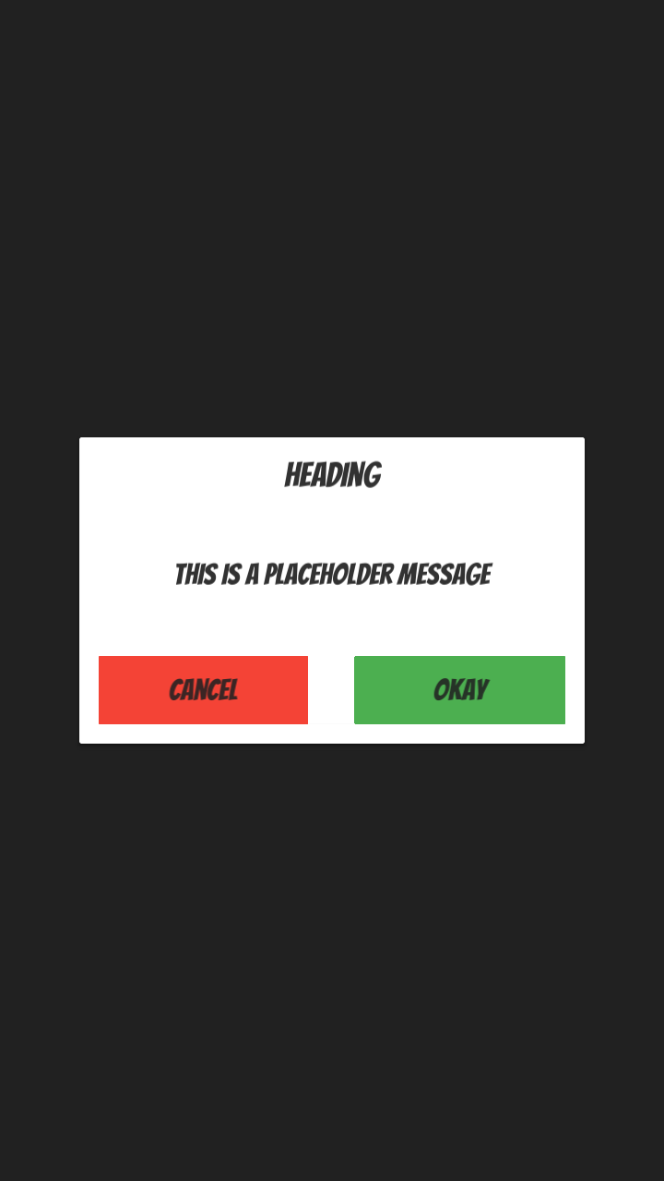 This placeholder message. It presents if I try to go back from the Login Scene, to get out of it I have to exit the game.

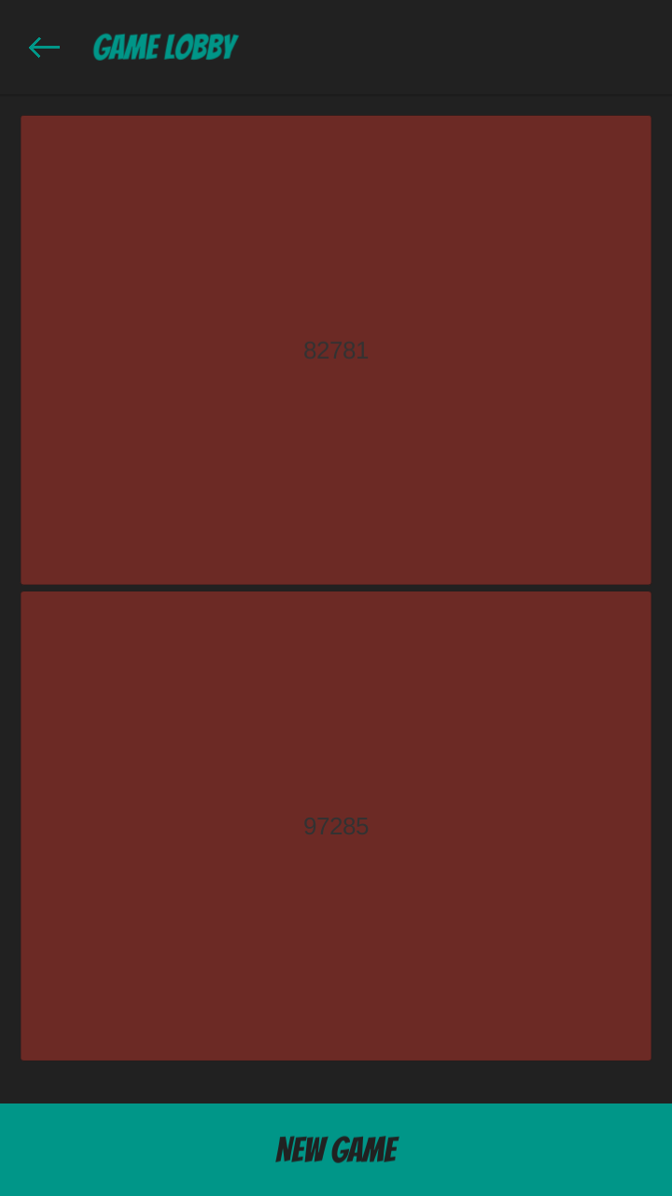These buttons need to be a fixed size

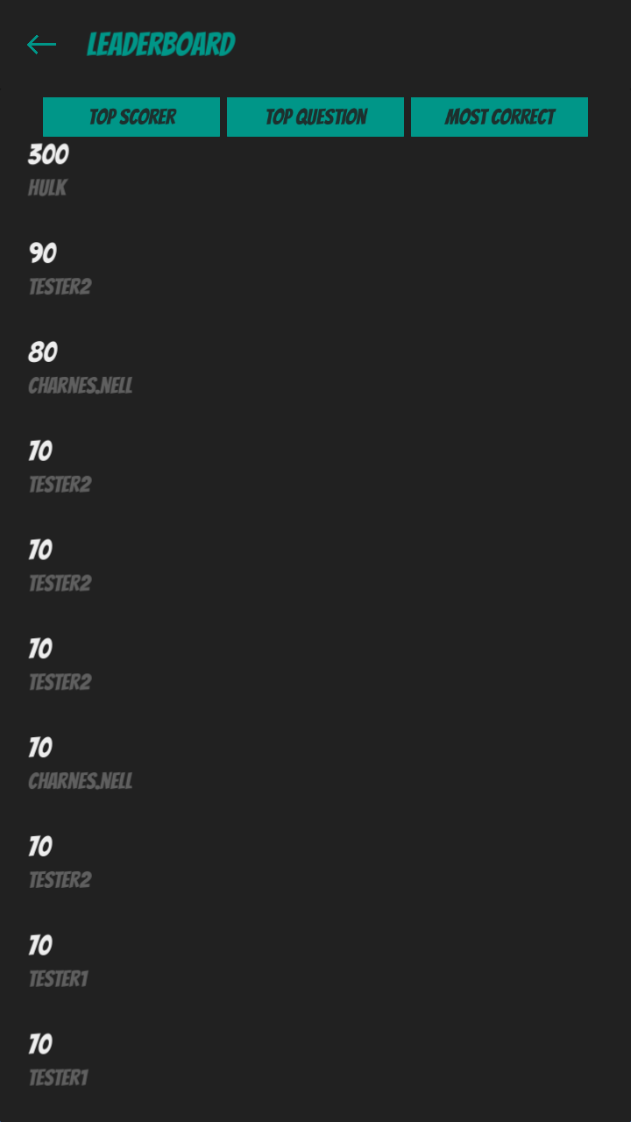It probably should indicate what ‘board’ your on

Maybe the list should be centred as there is a lot of empty space in this scene

The board itself appears not to be working

The buttons at the top don’t seem to work